

# Drawing a Medication or Vitamins from an Ampule

Follow these steps to draw up medications or vitamins.

Supplies: medication ampule, syringe with 2 needles (1 needle with a filter and 1 needle without a filter), 2 alcohol pads, and a sharps container

  drawing of a ampoule with label

 

1. Check your orders. Check your medication label. Make sure your medication label matches your orders, that the medication has not expired, and that there are no particles in the solution.
2. 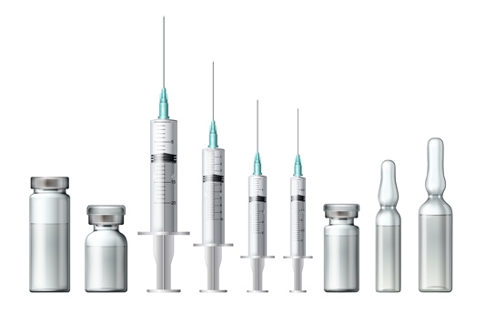Clean your work area with a cleaning solution and a clean paper towel. Wash your hands for 20 seconds with soap and water. Alcohol-based hand sanitizer is an alternative.
3. Gather your supplies: medication ampule, syringe with 2 needles (1 needle with a filter and 1 needle without a filter), 2 alcohol pads, and a sharps container.
4. Draw up your medication.

* Tap the top of the ampule to shake the medication to the bottom.
* Scrub the top of the ampule with the alcohol pad for 15 seconds. Wrap a new alcohol pad around the top of the ampule.
* Snap off the top of the ampule with your finger and thumb. Throw the top away in the sharps container. Place the ampule on your clean surface.
* Attach the filter needle to the syringe. Twist clockwise.
  + DO NOT TOUCH THE NEEDLE OR SYRINGE TIP! If you do, or if it touches a surface, throw the syringe away and use a new one.
* Remove the cover from the needle and place it on your clean working space.
* Insert the filter needle into the opening of the ampule. Draw back on the plunger the amount of medication ordered. Remove the syringe from the ampule. Push out air from the syringe.
* Place the clear cover back on the filter needle using the scoop method. Remove the filter needle from the syringe.
* Place a new non-filter needle on the end of the syringe. Follow the orders about next steps.

1. If you have just drawn up vitamins to add to intravenous fluids, find the rubber tip on the IV bag.
2. A person washing their hands under a running water faucet
    **WASH HANDS.**
3. Scrub the rubber tip of the IV bag for 15 seconds. Do not drop the rubber tip.
4. Remove the cover of the needle on the syringe and place it on your clean working space. Insert the needle into the rubber tip. Inject all the vitamins into the bag. Remove the entire syringe and throw it into the sharps container.
5. **WASH HANDS.**